**Way of Connecting Ec2 Instances.**

**Step 1 – Directly connect Ec2 to browser by choosing Ec2 Instance Connect.**

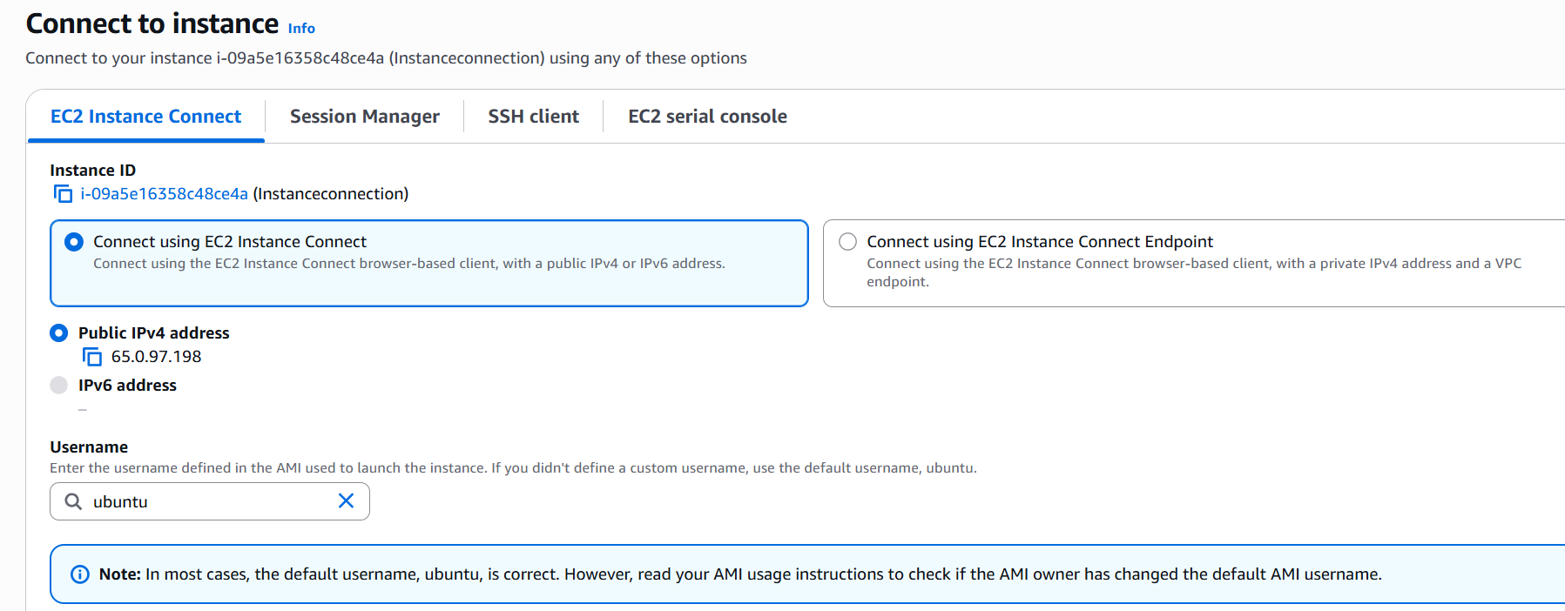

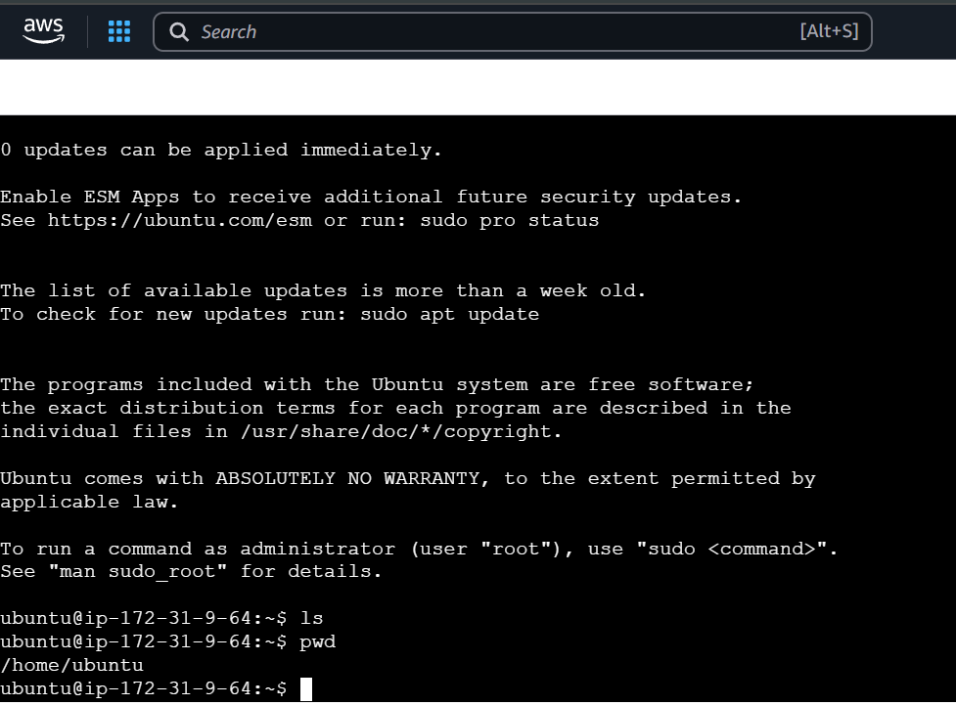

**Step 2 – Connect Ec2 by SSH Client. (for this we will use Ex- Putty).**

**Open Puttygen & load your key from system & save private key it will generate new ppk file.**

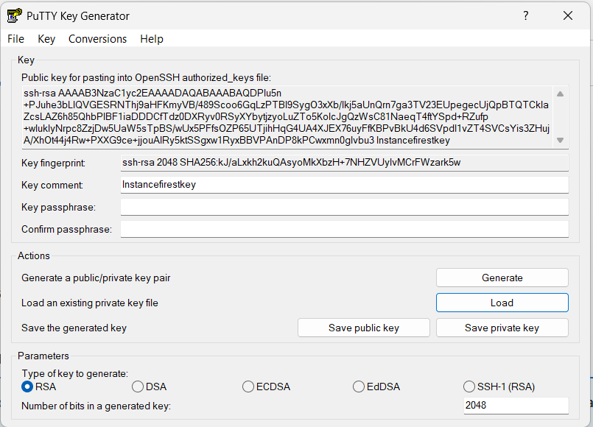

**Step 3 – Now open Putty paste public IP address. Go to SSH – Auth- Credentials.**

**Now browse your ppk file which you currently downloaded. Then click open.**

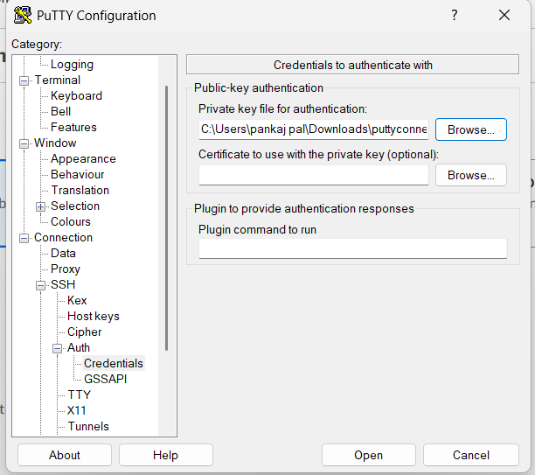

**Step 4 – Now Put your Username & here successfully I am able to login by Putty.**

